President’s Remark

REMINDERS
• • •
- Walking Trails – with Spring upon us and warmer weather approaching – be sure to visit our open areas.
https://bit.ly/2Qh4Zx7

- We all love pets in the neighborhood, but please remember that as spring approaches and windows are left open for sleeping to be mindful of barking during quiet hours. Also adhere to the leash laws and to pick up after your furry family members.

Connect with us on Facebook!
www.facebook.com/lakegardaimprovementassociation/

Lake Garda Improvement Association
Date: Tuesday, April 12th, 2022 Time: 7:30 PM | NOTICE OF GENERAL MEETING | Location: Farmington Senior Center, 321 New Britain Ave.

A note from Lee Gezelman:
The April General meeting will be on Tuesday, April 12th 2022 at 7:30pm at the Farmington Senior Center. The board is proposing a budget with an increase from $200.00 a year to $250.00 a year. We have not had an increase since 2011. As you all know prices have gone up generally and we do not make this decision lightly. Please note that the increase does not impact the senior members of the association with the discounted tax break.

Spring and Summer at the Lake
As you may have noticed the lake is down for the spring cleanup. We anticipate it to stay at this level until the first weekend of April. In the last year, the board has found out that Lake Garda falls under FEMA as a floodplain hazard area. What this means is that all property owners with lakefront property cannot build docks, sheds or walls that fall within the floodplain as designated by FEMA and must seek a permit through the appropriate town and also confirm the requirements with the LGIA Board.
  - If you have any questions about this, please email us at info@lgiact.com.

Events
We have missed our get togethers with the community over the past year. We are excited to share a few fun events coming up this year!
Easter Egg Hunt: April 9th at 10:30 am at Children’s Beach.

Outdoor Movie Night: May 20th at Children’s beach at 7:00pm. Rain date May 21st.

Regatta/Picnic: September 10th at 11:00am at Battistoni Beach.
If you haven’t already done so, please like our Facebook page and sign up for our e-blast so that you can be informed about upcoming events or notices. Or email us:
events@lgiact.com.

Board Meeting Schedule
The Board meets the second Tuesday of each month at The Farmington Senior Center at 7:00 PM unless otherwise specified.

- Tuesday – 5/10/22
- Tuesday – 6/7/22
- Tuesday – 7/12/22
- Tuesday – 8/9/22
- Tuesday – 9/13/22

A Note from the Tax Collector…
As a friendly reminder, please keep in mind that tax bills will be sent out in early May and payment is due May 15th. This is a great time to plan ahead for that expense. As the fiscal year nears an end, I would like to report that 96.1% of our LGIA members are fully paid. With that said, please be advised that the association will place a lien on any property that is more than 60 days past due. The lien fee is added to the taxes due and is currently $90 based on the fees charged by the towns.
For those who prefer to pay on-line, People's Bank has retained the FastPay system, so that option will continue to be available again this year. Thank you to everyone who has paid on time and is current with their LGIA taxes. You can always contact me via email at:
taxcollector@lgiact.com.
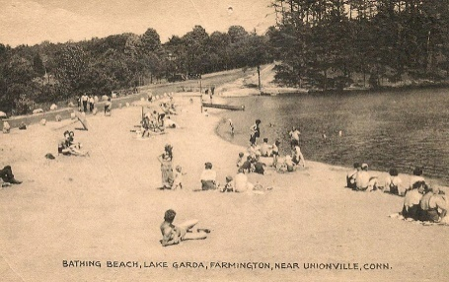

Boat Rack Registration

If you do not have a slot for your boat at one of the beach racks for this upcoming season please fill out the online form below.
https://bossk1600.wufoo.com/forms/lgia-boat-registration/
We will have a sticker with your boat number and beach choice for your boat available for pick up at the General Meeting in April. This is a first come basis for boat rack use.
All boats on the racks at the beaches must be marked with a sticker for the 2022 season with your boat number and beach choice. Any boats without stickers will be removed from the racks. There will be no boats left on the beaches. All boats much be on a rack.
If you still have boats on the racks that you are not using, we are asking if you would please remove them to make room for members who can benefit from that slot. Thank you for helping us keep our beaches uncluttered.
Any questions, please reach out to Claudia:
claudiasapple@gmail.com.
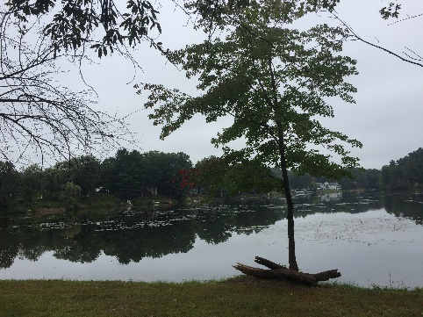
Budget
Please find the budget for 2022/2023 on the next page.
Do you love Lake Garda? So do we. We are looking to plan a service day to help tidy up the beaches, trails and other common areas around our beautiful lake.
It will be a chance to bring your favorite clean up tools and work together to keep Lake Garda looking good.
Please email our Director Reagan and add “Lake Garda Clean Up” in the subject line: ReaganFrey@gmail.com
He will follow up with you with details.

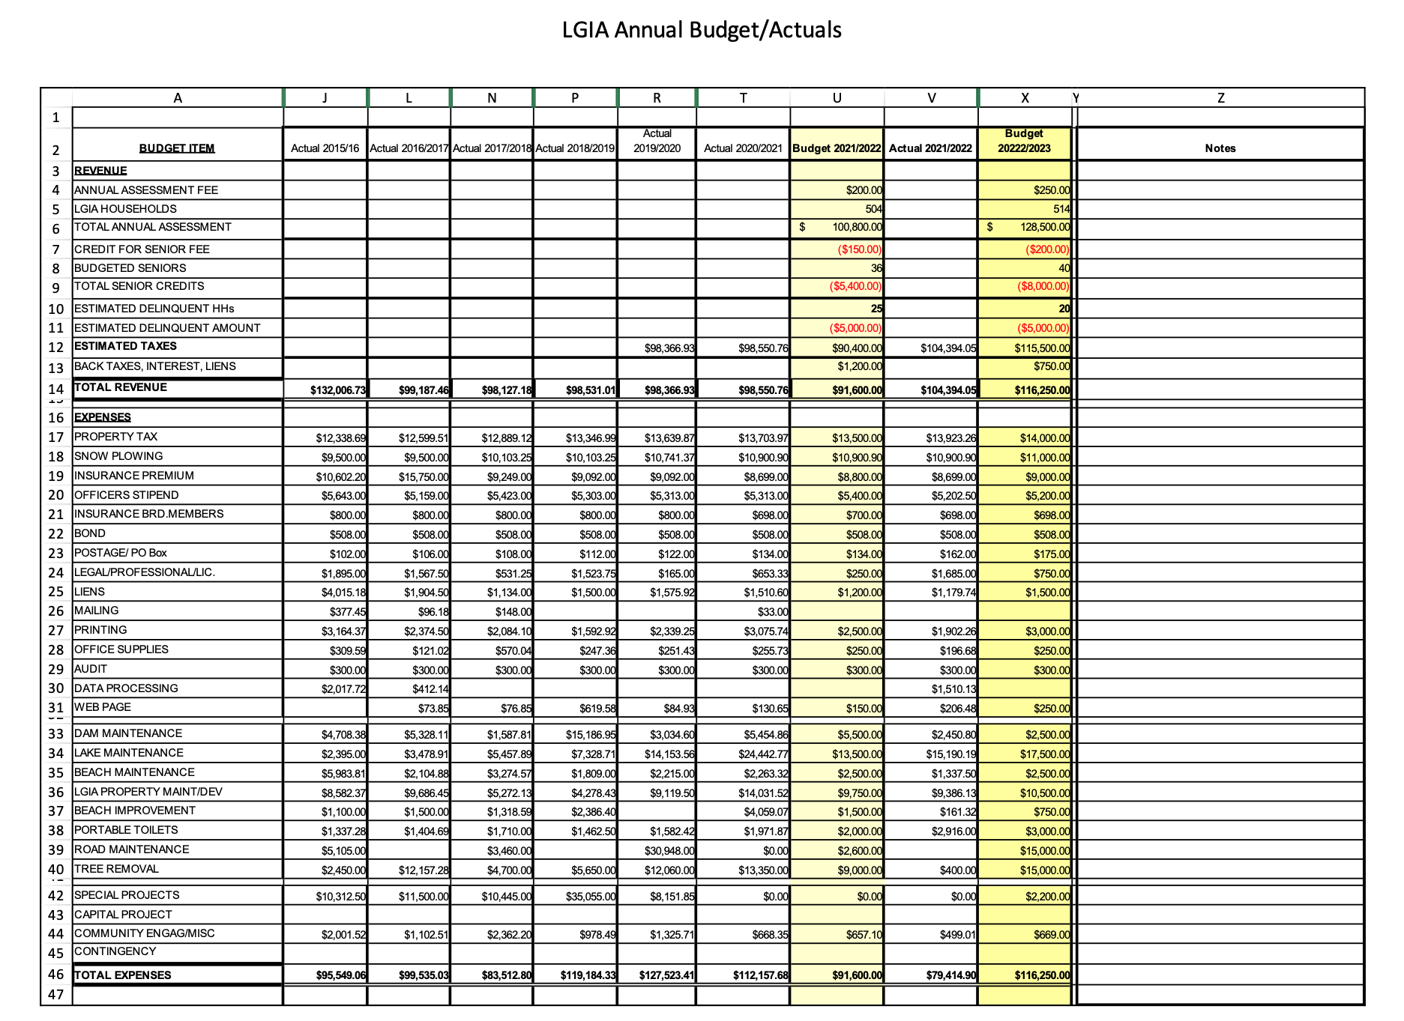

LAKE GARDA NEWS
Date: Tuesday, April 12, 2022 Time: 7:30 PM
PO Box 222 Unionville, CT 06085

NOTICE OF GENERAL MEETING
Date: Tuesday, April 12th, 2022 at 7:30 PM
Location: Farmington Senior Center
321 New Britain Ave, Unionville, CT

GENERAL MEETING AGENDA
• • •
Prior General Meetings Minutes
Solicit Items for New Business - LGIA Members (Non-board)
Treasurer’s Report
Tax Collector’s Report
President’s Report
Current Business Report
New Business - New Membership
Budget
Adjournment

