President’s Remark

REMINDER
• • •

AUTUMN LEAVES:
As the summer ends and autumn arrives, please remember not to blow/rake leaves into the water or near any of the lakefront areas where the leaves may blow or be washed into Lake Garda by wind or storm runoff.

Minimizing the amount of leaf buildup helps us to limit the degree of nutrient-rich sediment that settles to the lake bottom. This sediment worsens the algae and invasive aquatic plant issues that have been plaguing the lake for years.

Please help us maintain the lake for years of future use!

Connect with us on Facebook!
www.facebook.com/lakegardaimprovementassociation/

Lake Garda Improvement Association
Date: Tuesday, October 11, 2022: 7:30 PM | NOTICE OF GENERAL MEETING | Location: 321 New Britain Ave, Farmington, CT

  - A note from Lee Gezelman, President

Good day, all,

Our next General Board Meeting will be held on Tuesday, October 11th at 7:30 PM at the Farmington Senior Center, 321 New Britain Ave, Farmington CT. We encourage all members to attend the meeting as we will be electing new officers and directors for the 2022/2023 LGIA Board.

Our slate for Officers:
For President: Lee Gezelman
For Vice President: John Cragin
For Treasurer: AJ Singh
For Secretary: Chip Anthony
For Tax Collector: Marty Duchow

*These officers make a one-year commitment to the board.

Our slate for Board of Directors:
Claudia Castrogiovanni
Reagan Frey

*All Directors make a three-year commitment to the board.
There will also be a call for nominations at the meeting itself.

Board Meeting Schedule
The LGIA Board meets at 7:00 PM at Farmington Senior Center during the year. Dates are as follows:

- Tuesday – 10/11/22
- Tuesday – 11/8/22
- Tuesday – 12/13/22
- Tuesday – 1/10/23
- Tuesday – 2/14/23
- Tuesday – 3/14/23
- Tuesday – 4/11/23
- Tuesday – 5/9/23
- Tuesday – 6/13/23
- Tuesday – 7/11/23
- Tuesday – 8/8/23

Please reach out to the LGIA board with any questions, concerns, ideas, etc. at info@lgiact.com.

Good Neighbors/
Common Courtesy
In our community the houses are close together and with that in mind, we need to be aware that noise travels to our neighbors.

When you are enjoying picnics, parties and family get togethers outside in your yard, please keep in mind your neighbors.
Especially as it gets into the evening, please be mindful about how your voice and music travels.

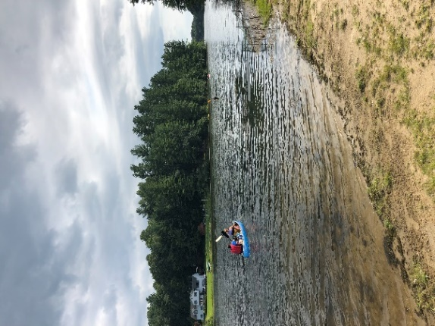

Events
We had hope everyone had a great summer on the lake. We had some very successful events this season with our egg hunt, movie night, and the picnic/regatta poker run.

We thank all of the lake members who attended and all those that made the events happen.

Please stay tuned to our e-blast or Facebook page for more events coming up.

E-Blast
We recently sent out an e-blast email about the lake being treated. If you didn’t receive the email, you likely aren’t on our email distribution list.

Please send an email to info@lgiact.com and we can add you to the list.

A Note from the Tax Collector…
With LGIA tax season winding down, approximately 50 households have not yet paid their taxes for this year. Out of respect for those who have paid and to protect LGIA's interests, liens will placed on properties that have not paid their taxes.
To avoid a lien against your property, you need to pay your taxes ASAP. Send payment to LGIA, POBox 222, Unionville, CT 06085, or follow the instructions to pay online (fee applies) at https://paynow.peoples.com/ebpp/LakeGardaImp/.
To find out your current balance or to confirm whether you're paid in full for this year, or arrange for a payment plan, please contact the tax collector at taxcollector@lgiact.com by September 30.
If you've already paid, thank you. And please reach out to your neighbors to remind them as not everyone in the association has email.
If you have any questions or need to arrange a payment schedule, please contact me at taxcollector@lgiact.com

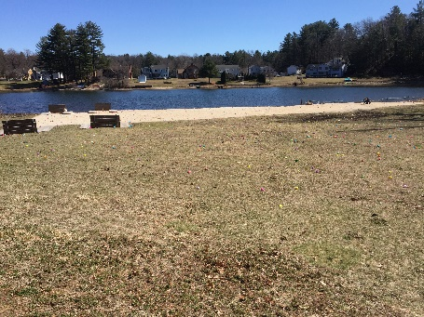

Boats and Boat Racks
The boat racks at beaches are open to all LGIA members, so please be considerate of the other boats.
As a reminder, all boats on the boat racks must have an LGIA sticker on them and be registered with the association. If your boat has previously been registered, you do not need to register again. If your boat is not registered please contact Claudia at info@lgiact.com.
In October, the association will remove all unmarked boats even if they are locked to the rack.

Regatta/Movie Night Photos
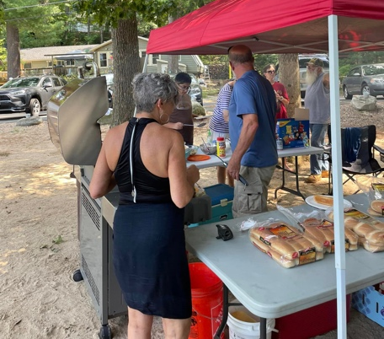
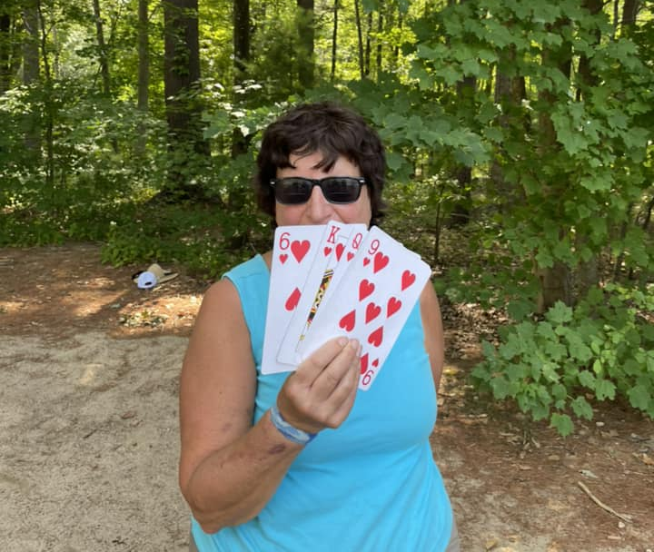
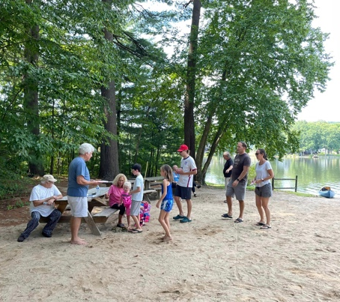
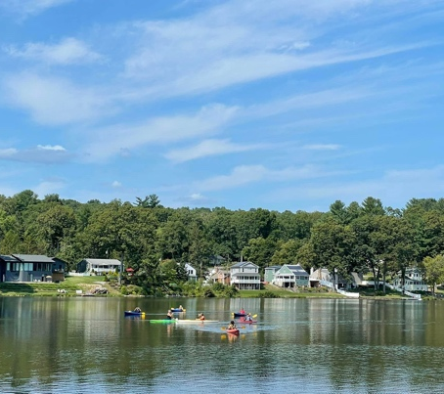
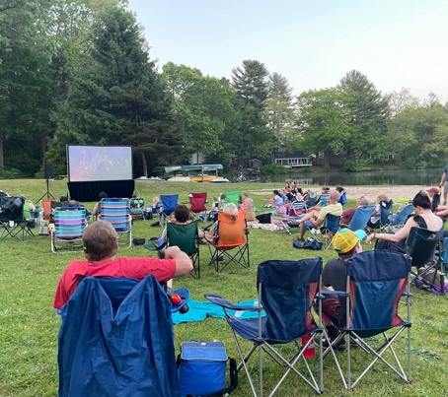

LAKE GARDA NEWS
Date: Tuesday, October 11, 2022 Time: 7:30 PM
PO Box 222 Unionville, CT 06085

LAKE GARDA NEWS
Date: Tuesday, October 11, 2022: 7:30 PM
PO Box 222 Unionville, CT 06085

NOTICE OF GENERAL MEETING
Date: Tuesday, October 11th, 2022 at 7:30 PM
Location: Farmington Senior and Community Center
321 New Britain Ave, Farmington CT

GENERAL MEETING AGENDA
• • •
Prior General Meetings Minutes
Solicit Items for New Business - LGIA Members (Non-board)
Treasurer’s Report
Tax Collector’s Report
President’s Report
Adding New Properties to LGIA
Transferring Property
Election of Officers and Board Members 2022/2023
Adjournment

