# President’s Remark

# 

# **REMINDERS**

• • •

* As a reminder all beaches and their parking lots are closed from dusk until dawn. It has been noticed that there has been an uptick of residents using the parking lots for overnight parking or extended hours during the day. Parking lots are for the use of members. Please remember to park your vehicles on your own property and be courteous of others.

**Connect with us on Facebook!**

[www.facebook.com/lakegardaimprovementassociation/](http://www.facebook.com/lakegardaimprovementassociation/)

Lake Garda Improvement Association

|  |  |  |
| --- | --- | --- |
| Date: Tuesday, April 11th, 2023 Time: 7:30 PM | **NOTICE OF GENERAL MEETING** | Location: Farmington Senior Center, 321 New Britain Ave. |

*A note from Lee Gezelman:*

The April General meeting will be on Tuesday, April 11th 2023 at 7:30pm at the Farmington Senior Center. The upcoming year’s budget will be discussed at the meeting and voted on.

# Spring and Summer at the Lake

As you may have noticed the lake is down for the spring cleanup. We anticipate it to stay at this level until the first weekend of April. As a reminder, In 2021, the board has found out that Lake Garda falls under FEMA as a floodplain hazard area. What this means is that all property owners with lakefront property cannot build docks, sheds or walls that fall within the floodplain as designated by FEMA and must seek a permit through the appropriate town and also confirm the requirements with the LGIA Board.

*If you have any questions about this, please email us at* ***info@lgiact.com****.*

Events   
We are excited to share a few fun events coming up this year!

**Easter Egg Hunt:** April 1st at 10:30 am at Children’s Beach. (Rain date April 2nd at 1:00 pm)

**Regatta/Picnic**: September 9th at 11:00am at Battistoni Beach.

**Outdoor Movie Night:** Late summer/fall.

If you haven’t already done so, please like our Facebook page and sign up for our e-blast so that you can be informed about upcoming events or notices. Or email us:

**events@lgiact.com.**

# Board Meeting Schedule

The Board meets the second Tuesday of each month at The Farmington Senior Center at 7:00 PM unless otherwise specified.

* **Tuesday – 5/9/23**
* **Tuesday – 6/13/23**
* **Tuesday – 7/11/23**
* **Tuesday – 8/8/23**
* **Tuesday – 9/12/23**

# A Note from the Tax Collector…

Did you know that State law provides a property tax credit program for Connecticut owners in residence of real property, who are elderly (65 and over) or totally disabled, and whose annual incomes do not exceed certain limits. This program is administered by your town. Each year we get the list of qualified residents from the towns and, if you qualified for the program, you will automatically be billed a reduced tax rate for your LGIA taxes. Forty-two members qualified for the program last year!

As the tax year nears an end, we find that 93.4% of our LGIA members are fully paid. However, of thirty-four delinquent accounts, eleven have gone to a collection agent. Paying on time saves you significant money – the state-mandated interest rate for late accounts is 18% and the association will place a lien on any property that is more than 60 days past due. The $90 lien fee is added to the taxes due. Accounts owing more than $500 are handled by the collection agent and the property owner is responsible for all collection and legal fees.

As always, tax bills will be sent out in early May and payment is due May 15th. For those who prefer to pay online, the link will be specified in the bill and is also available on the association’s internet home page. The payment system has a new look and feel as M&T uses a different system than the FastPay system used by Farmington Bank and People’s Bank in past years.

Thank you to everyone who has paid on time and is current with their LGIA taxes. You can always contact me via email at: **taxcollector@lgiact.com.**

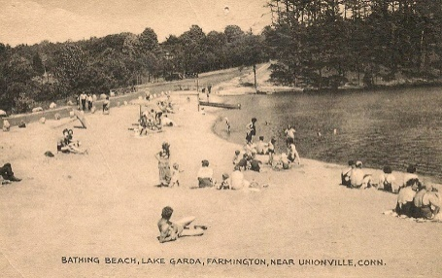

# Boat Rack Registration

The boat racks at beaches are open to all LGIA members, so please be considerate of the other boats.

As a reminder, all boats on the racks must have an LGIA sticker on them and be registered with the association. **If your boat has previously been registered, you do not need to register again.**

If your boat is not registered please do so here:

https://bossk1600.wufoo.com/forms/lgia-boat-registration/

*Any questions, please reach out to Claudia:*

**claudiasapple@gmail.com*.***

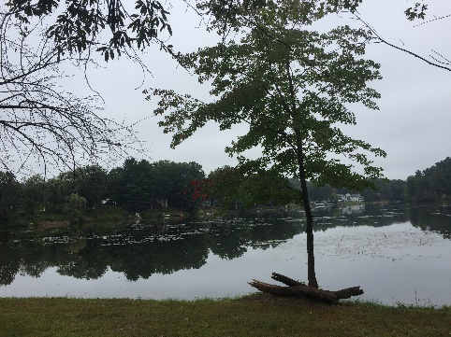

Do you love Lake Garda?  So do we.  We are looking to plan a service day to help tidy up the beaches, trails and other common areas around our beautiful lake.

Please email our Director Reagan and add “Lake Garda Clean Up” in the subject line: **ReaganFrey@gmail.com.** He will follow up with you with details.

Budget

Please find our 2023/2024 budget on the next page



**LAKE GARDA NEWS**

Date: Tuesday, April 11, 2023 Time: 7:30 PM

PO Box 222 Unionville, CT 06085

|  |  |  |
| --- | --- | --- |
|  |  |  |
|  |  |  |

***NOTICE OF GENERAL MEETING***

***Date: Tuesday, April 11th, 2023 at 7:30 PM***

***Location: Farmington Senior Center***

***321 New Britain Ave, Unionville, CT***

# GENERAL MEETING AGENDA

• • •

Prior General Meetings Minutes

Solicit Items for New Business - LGIA Members (Non-board)

Treasurer’s Report

Tax Collector’s Report

President’s Report

Current Business Report

New Business - New Membership

Transferring Property

Budget

Adjournment